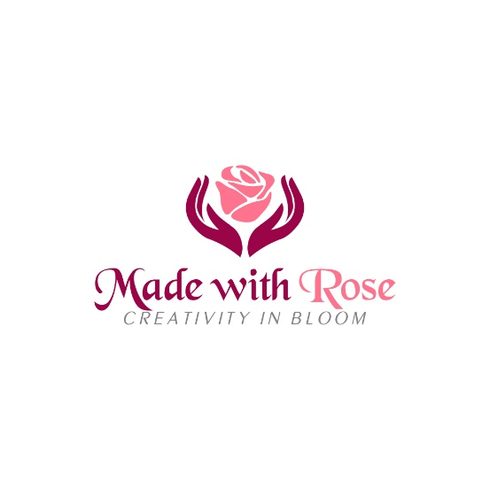

Flower Craft workshops

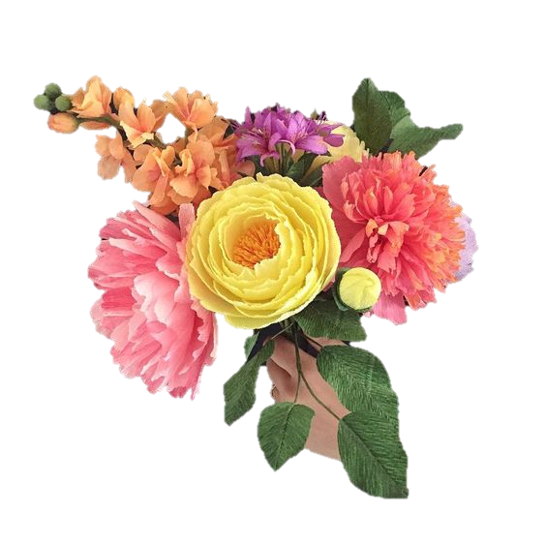
About the Course
Whether you would like to learn the very basics or you wish to add to your existing skills in creating beautiful blooms, my ‘Flower Craft’ classes will teach you how to make a variety of different silk flowers each month. I will teach you a range of techniques as well as some ‘tricks of the trade’ used to make simple flowers as well as more complex blooms. I will also cover those all-important finishing touches.
My classes offer a personal approach. Limiting numbers ensures all participants receive ‘hands on’ training and the time necessary to learn all the techniques. Having small groups provides a friendly and relaxed atmosphere where you can have a stress-free day. You will be able to develop your creativity and learn with confidence. You will leave with your blooms, ready to put your new skills to work in the creation of everlasting flowers, either for yourself, a special occasion or a gift.
Whether you book on your own or with a friend you're guaranteed a great day full of learning and fun.
What's included in the price?
This course includes full tuition, all materials to make a posy of flower to take home with you on the day. Light refreshments will be available on arrival and there is tea and coffee throughout the day. We will have a short break for lunch (lunch not included, so please bring some with you)
Please do let me know if it is a special occasion and you would like some help to organise the birthday cake and candle blowing!
Location: This workshop is held in my home in Lechlade on Thames
Price: £55 per person. (Full day at the monthly workshop)
£35 per person (half Day, only certain workshops)
Discounts available for multiple bookings on the same day – please enquire for details.
Max numbers: 6
Time:10am – 5pm

Booking your own date
I offer bespoke dates at £150 for the day for up to two people. This can be a 1:1, or you can bring a friend.
Please contact me for availability if you would like a different date or mid-week. booking.
To book your place contact me:
Phone: 07881208076
Email: Madewithrose@outlook.com

